COMPUTER HARDWARE AND
COMPUTER SOFTWARE
LAB# 01 & LAB# 02



BATCH# 24
FALL 2022
COMPUTER FUNDAMENTALS LAB

Submitted by: ALESHBA AAINA
ETEA ID: 55012
Section: B

“On my honor, as a student of UET, I have neither given nor received unauthorized assistance on this academic work.”

STUDENT SIGNATURE: ______________

Submitted to:
Engr. Abdullah Hamid
25 NOVEMBER 2022

Department of Computer Systems Engineering
University of Engineering and Technology, Peshawar
Task# 01: MY PERSONEL COMPUTER

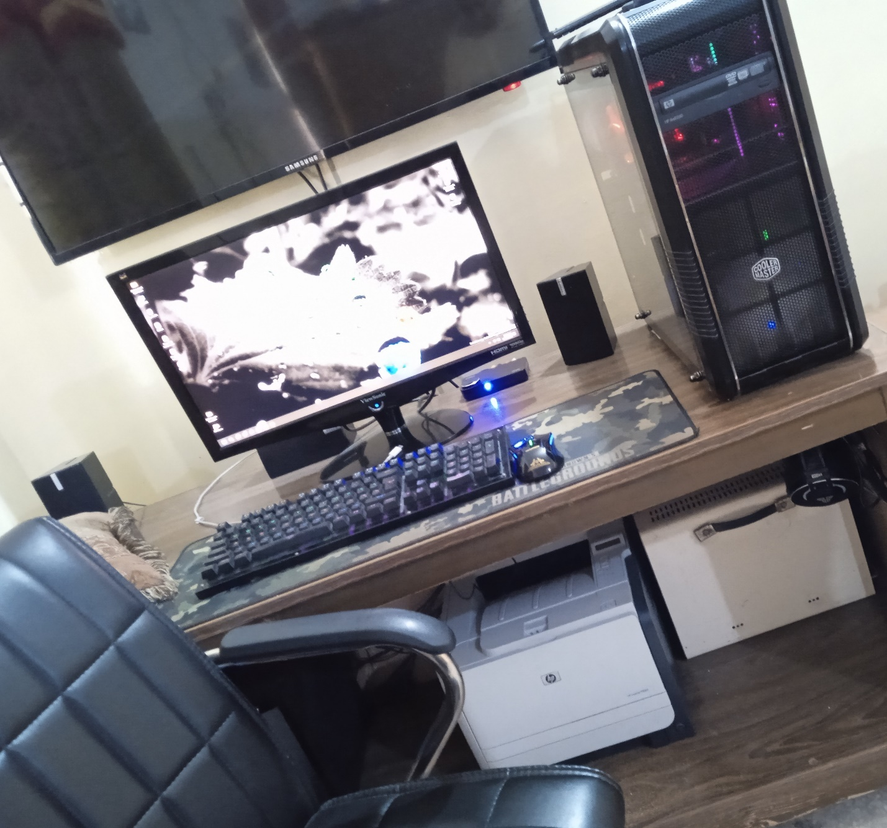

DEVICE SPECIFICATIONS:
- Processor: AMD Ryzen 2600
- RAM: T-Force Zues 32 MHz 16GB
- Primary Storage: 256GB NVME 2.0
- GPU: GTX 1060 6GB Zotac AMP
- Secondary Storage: 2TB Western Digital Black Series
- Power Supply Unit: Thermaltake 630 Watts Modular
- Motherboard: MSI Mortar Max B450
- Case: Cooler Master
- Cooling System: Cooler Master Hyper 212 EVO

CONNECTED PERIPHERALS:
- Keyboard: HP Pavilion 550 Gaming Keyboard
- Mouse: Newmen G7 Optical USB Gaming
- Headset: Fantech Octane HG23 Programmable
- Monitor: ViewSonic VX-57 MHD 1080p Full HD

Task# 02: MY PHONE SPECS
- SOC: MediaTek Helio G25
- CPU: Octacore 12nm
- Device Model: Redmi 10A
- Operating System: Android 11, MIUI 12.5
- Display Size: 6.53”
- Display Resolution: 720*1600 pixels
- Main Camera: 13 MP
- Selfie Camera: 5 MP
- RAM: 4GB
- Storage: 128GB
- Battery: Li-Ion 5000mAh
- GPU: PowerVR GE8320
- Color: Slate Grey

Task# 03: INSTALLING WINDOWS
- Take any booting device like USB flashdrive and insert it into cmputer.
- Restart the computer.
- Wait for the computer to start show a message where it tells you to ‘press any key’ to boot the flash drive, when you press the key, the computer boots the USB instead of the hard drive.
- Now wait for the installation process to begin. After few minutes the ‘Install Now’ prompt will appear. So click ‘Install Now’.
- As its Followed by the Window’s Startup screen, Now enter the desired three options by selecting a language of choice and click ‘next’.
- After that, now we have to select an operating system with it’s specific architecture.
- Finally agree to the license terms and select the installation type for example, upgraded-type or customized-type.
- Now manually cutomize and select a partition drive for letting the installer know where disk the windows files will be copied.
- Finally, click ‘Next’ to start the Installation.
- Now the Setup is being installed. And it’s just a matter of time that the setup finishes and then you customizeyour account, PC name, password and few more data and hence the installation process is completed.

Step 3:
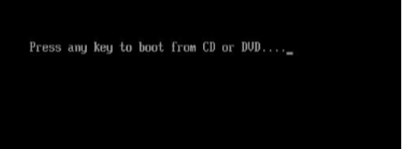
Step 4:
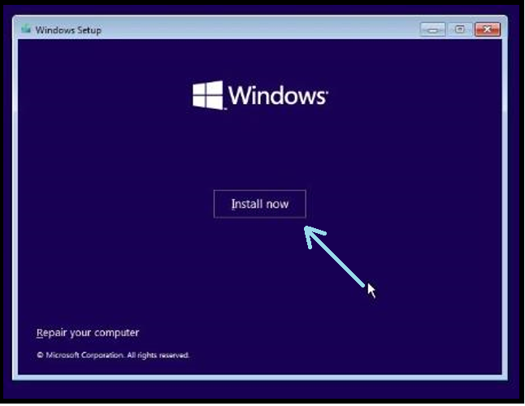

Step 5:
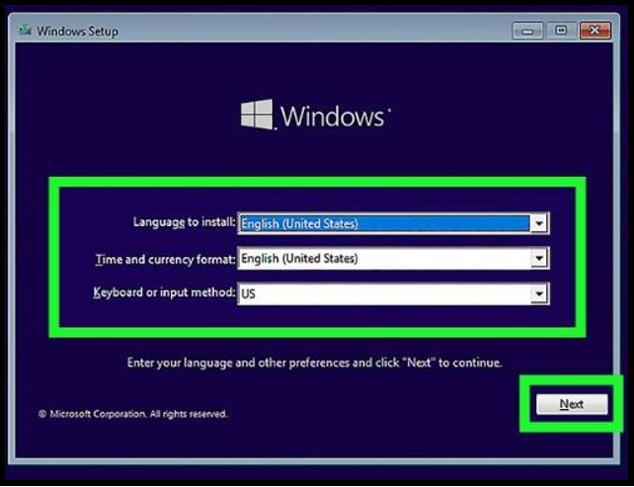

Step 6:
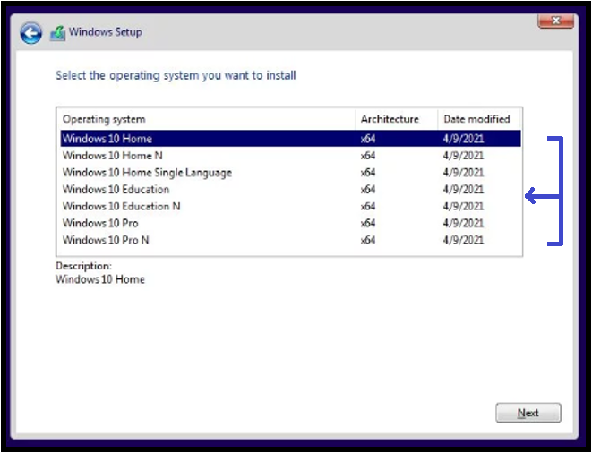
Step 7:
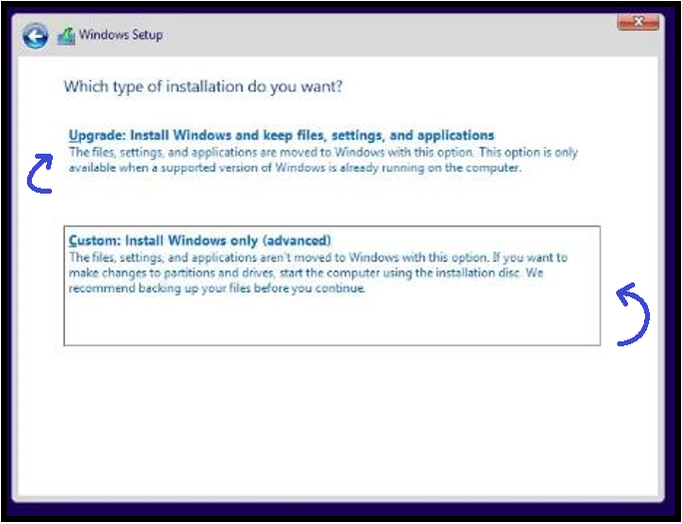

Step 8:

